Call for Applications

TEACHER TRAINING SEMINAR

Anne Frank House, in cooperation with local partner organizations from Bosnia-Herzegovina (Youth Initiative for Human Rights -YIHR & Humanity in Action - HiA), Croatia (Croatian Education and Development Network for the Evolution of Communication - HERMES), Macedonia (Youth Educational Forum - MOF) and Serbia (Open Communication – OK), invites high school teachers to apply to attend one of the three upcoming Teacher Training Seminars, held within the EU-funded project ‘’Historija, Istorija, Povijest – Lessons for Today’’ (hereafter: HIP).

The HIP project consists of several innovative educational methodologies, modeled after the educational approach implemented in the Anne Frank House, whose objective is to raise awareness and encourage discussion about the recent history of nationalism, discrimination, prejudice and stereotypes in the region of former Yugoslavia. The educational materials were also created to promote critical thinking about historical events and their relevance for contemporary challenges. The overall goal was to create out-of-the-box, interdisciplinary, pluralistic, civic-education oriented history education materials/methodologies through a combination of both formal and non-formal education elements.

Topics & Methods that will be presented at the Teacher Training Seminars
Each seminar will feature the introduction to the ‘Anne Frank – a History for Today’ traveling exhibition, and its accompanying peer education methodology. Furthermore, participants will be introduced to the Anne Frank House Memory Walk methodology of discussing commemoration and remembrance practices through interactive exploration of monuments. Furthermore, several lesson plans will be presented, each outlining a 45 minute class on a subject that relates to the history of post-1945 Yugoslavia, or its breakup. Participants will receive educational materials in local languages, to take home after the seminar.

Who can apply?
We invite high school teachers (and in some cases, teachers of final grades of elementary school education), from the fields of history, civic education, philosophy, ethics and literature who will find the topics and materials the seminar will cover useful in their work. Teachers from other disciplines are welcome to apply too, if they can demonstrate that attendance in the seminar will be useful in their work. Finally, current students and future teachers of history or civic education are also welcome to apply. Applicants need to be based in/working in Bosnia-Herzegovina, Croatia, Macedonia or Serbia.

Location of the Teacher Training Seminars
There will be three seminars in total, each taking place in a different city:
February 17 – 21, 2016 in Zagreb, Croatia
March 16 – 20, 2016 in Mostar, Bosnia-Herzegovina
April 20 – 24, 2016 in Belgrade, Serbia

If selected, you will attend one of the seminars.

Accommodation & Travel Costs
The cost of the accommodation in ** or *** star hotels is borne by the project organizers and the hosting organization. Participants will be housed in single or shared (double) occupancy rooms. All meals during the seminar are covered by the hosting organization. Travel will be organized through travel agencies and mini-van transport, to the venues of the seminar. In exceptional cases, if a participant prefers arriving with their own car, we might be able to provide travel cost reimbursement – but please announce this well in advance, so that we can discuss it accordingly.

Language of the Seminar
All the workshops will be taught in either Bosnian/Croatian/Serbian or in English. Should you need assistance with translation, an interpreter will be assigned to you.

Deadline to Apply & Contact Information
Please fill in the application form by January 10th 2016, 17:00 CET. Once filled in, send it to the local project coordinator in your country:

Mr. Kerim Somun, Bosnia-Herzegovina kerim@yihr.org
Mr. Tvrtko Pater, Croatia hermes.communiaction@gmail.com or ornius@gmail.com
Ms. Sanja Stefanovic, Macedonia sanja_stefanovik@mof.org.mk
Mr. Boris Mikovic, Serbia mikovic@ok.org.rs

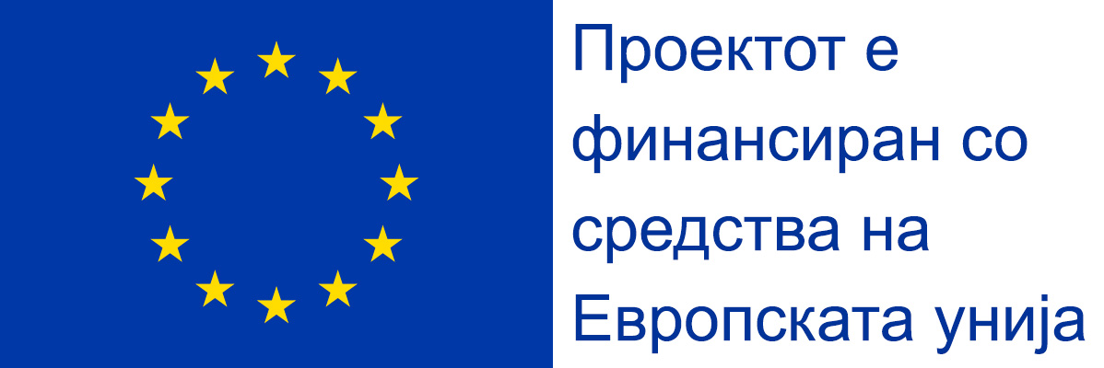

Application for the ‘Historija, Istorija, Povijest – Lessons for Today’ Teacher Training Seminar
Name and Surname
Contact information
(email address & telephone)
School where you teach:
City and Country:
Years of working experience:
What do you teach?
What is your interest in applying for the seminar? What do you hope to gain from attending it?
Maximum 250 words
There is some space for teachers to present their own methods and approaches to teaching about post-1945 Yugoslavia or its breakup. Would you be interested in presenting? If yes, please write a brief proposal of your presentation topic.
Maximum 300 words
*optional*
Please select 2 preferences for the seminar venue* | Zagreb, February 17 – 21, 2016  Mostar, March 16 – 20, 2016  Belgrade, April 20 – 24, 2016
Travel preference  (choose one) | Organized mini-van passenger service  Personal car
Dietary restrictions or preferences
Knowledge of English language
(scale: 1=poor ; 5= excellent)
Knowledge of Bosnian/Croatian/Serbian
(scale: 1=poor ; 5= excellent)
How did you hear about this seminar?
*We will do our best to comply with applicants’ set preferences but cannot ensure we will be able to meet everyone’s preferred choices.

